# Real World Context

What is data modeling?

## Real World Context

Why are data modeling and business intelligence skills is important for days knowledge worker?

## What is Digital Literacy?

* Digital literacy is having the knowledge, skills and confidence to keep up with changes in technology.

## Digital Literacy

### Tech Skills

* Our ability to use hardware, software and infrastructure

### Evaluation of Information

* Our ability to recognize truth from fiction

### Authorship Rules

* Our demonstrated understanding of and respect for the rights and obligations of using and sharing intellectual property.

### Online Social Responsibility

* Our responsibility for cultivating and managing identity and reputation while being aware of permanence of actions in an online world.

## Saying

It’s a VUCA world

* The world we live in is increasingly volatile, uncertain, complex, and ambiguous

## Notes

* We are all facing an unprecedented time of change
* The pain of change is mandatory
* It’s the suffering that is optional
* If you don’t like change you are doing to like irrelevance even less

## Data Modelling

* The process of creating a data model for an information system by applying certain formal techniques.
* Its about shaping and storing data in an organized way
* **At a high level need to understand:** Firms benefit from data organized in a systematic way so that we can all get our answers to the questions

## Business Intelligence

* Business Intelligence (BI) comprises the strategies and technologies user by enterprises for the data analysis of business information. BI technologies provide historical, current, and predictive views of business operations.

## Data Science

* Data science is the use of scientific methods to obtain useful information from computer data, especially large amounts of data.

<https://dictionary.combridge.org/dictionary/english/data-science>

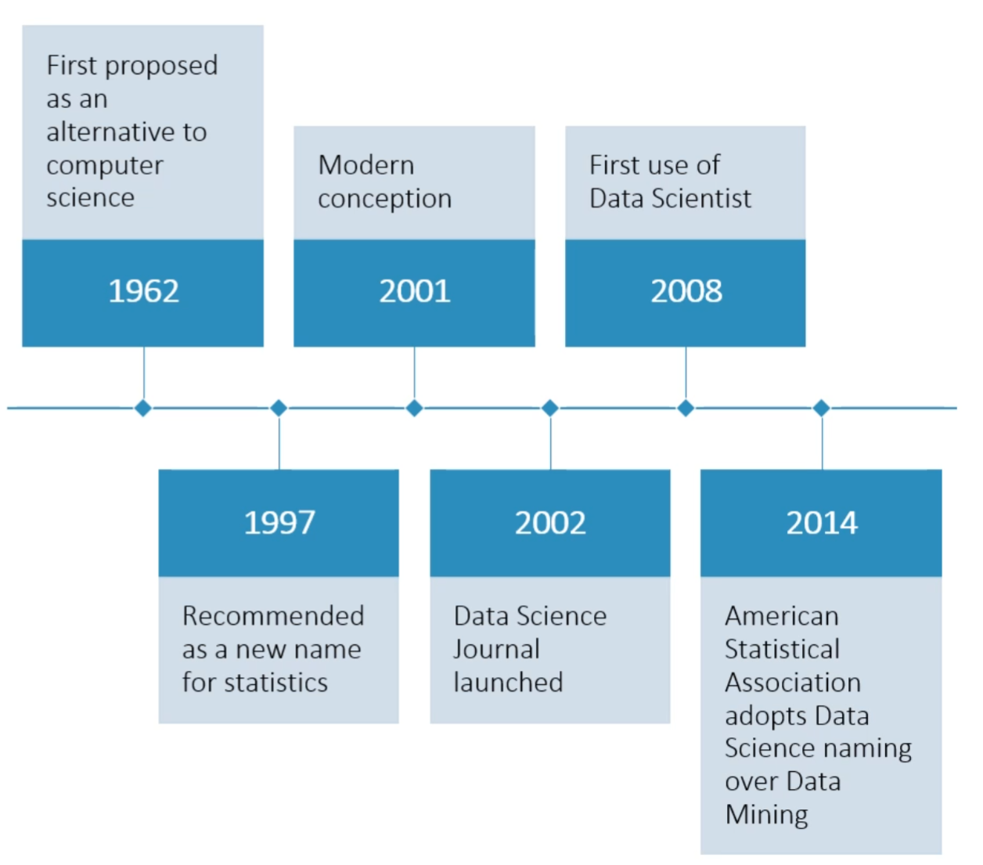

* Consists of computer science and statistics

## The Rise of the Data Scientist

1. Topped Glassdoor’s top jobs list from 2015 to 2019.
2. Job postings increased 75 percent between 2015 to 2018.
3. Continues to lead the tech industry in starting salary
4. Is a creative, challenging, rewarding position

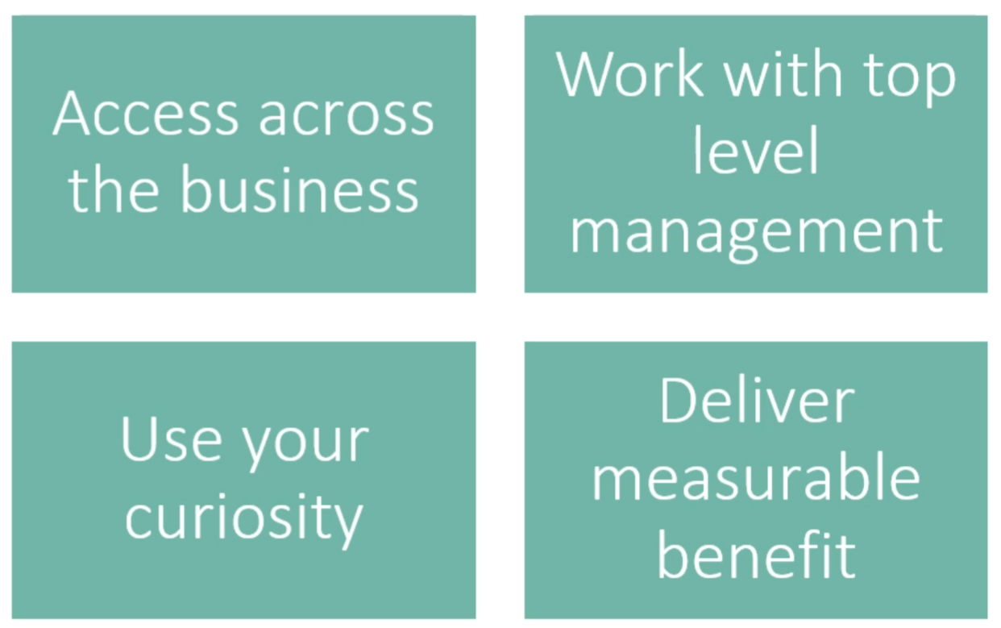

## Top 5 most Scarce Skills

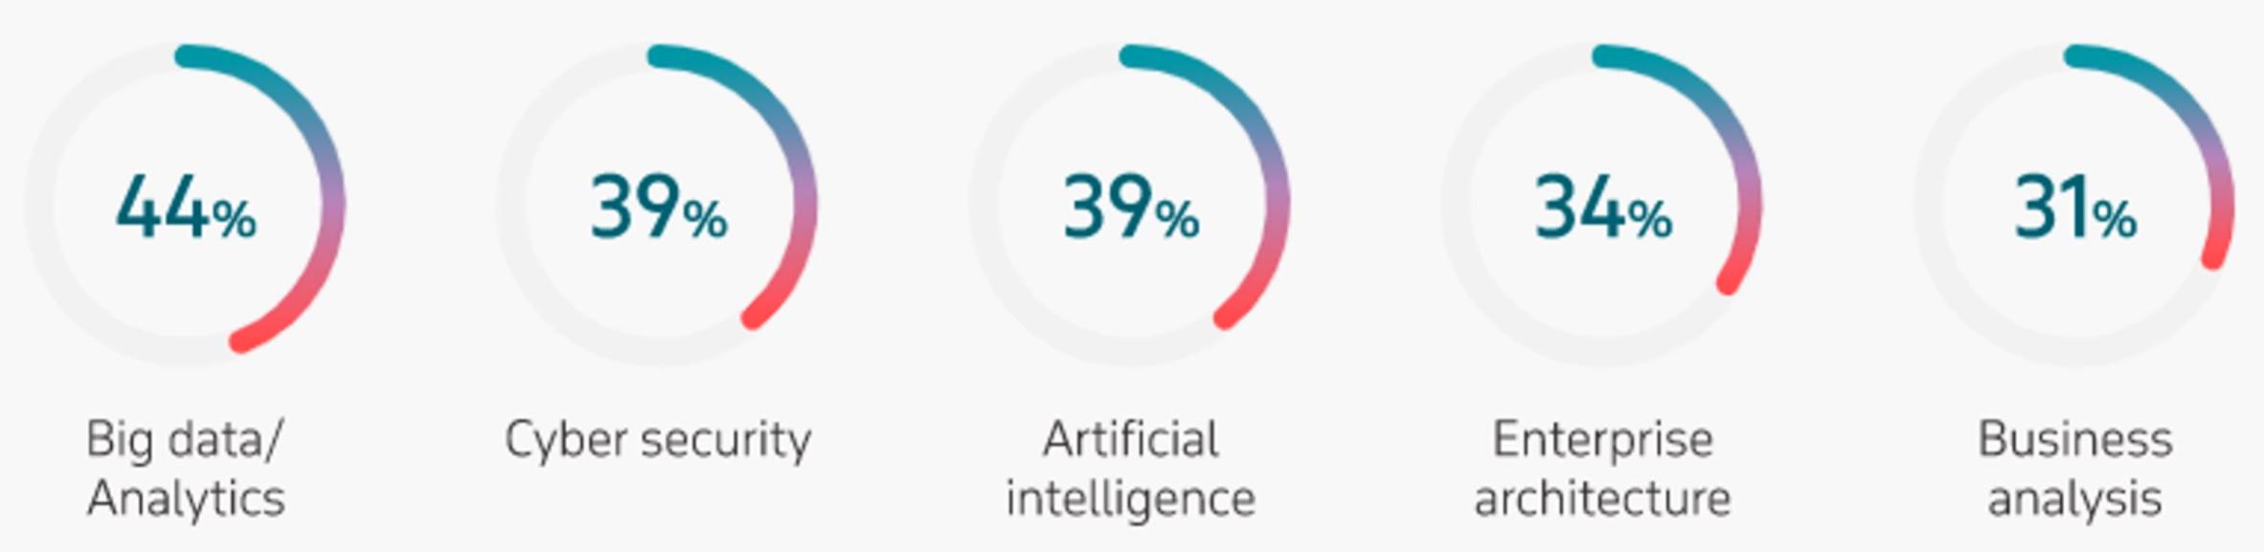

* The path to success for any organization, assuming that it involves the pursuit of competitive advantage and that arguably modern competitive advantage is tied to information, that means more than ever before our success is not only tied to our ability to access model and interpret the information but how quickly and confidently, we are able to act on the questions that we have.

## Gartner Predictions

* By 2024, AI identification of emotions will influence more than half of the online advertisements you see.
* By 2023, individuals activities will be tracked digitally by an “Internet of Behavior” to influence benefit and service eligibility for 40% of people worldwide.
* 2023, a self-regulating association for oversight of AI and machine learning designers will be established in at least four of the G7 countries.
* Through 2021, digital transformation initiatives will take large traditional enterprises, on average, twice as long and costs twice as much as anticipated.
* Through 2022, only 20% of analytic insights will deliver business outcomes
* If you look at organizations that have been around for a while and have used technology they will have legacy investments that will be hard for them to move away from. This doesn’t necessarily have anything to do with the technology or the ability to serve insightful, good looking visualization. Our challenge is really more with are we asking the right questions of our data.

## Data Access

* Our access to data can have a really big impact. Just for fun here are some examples of how impactful our interaction with data can be.

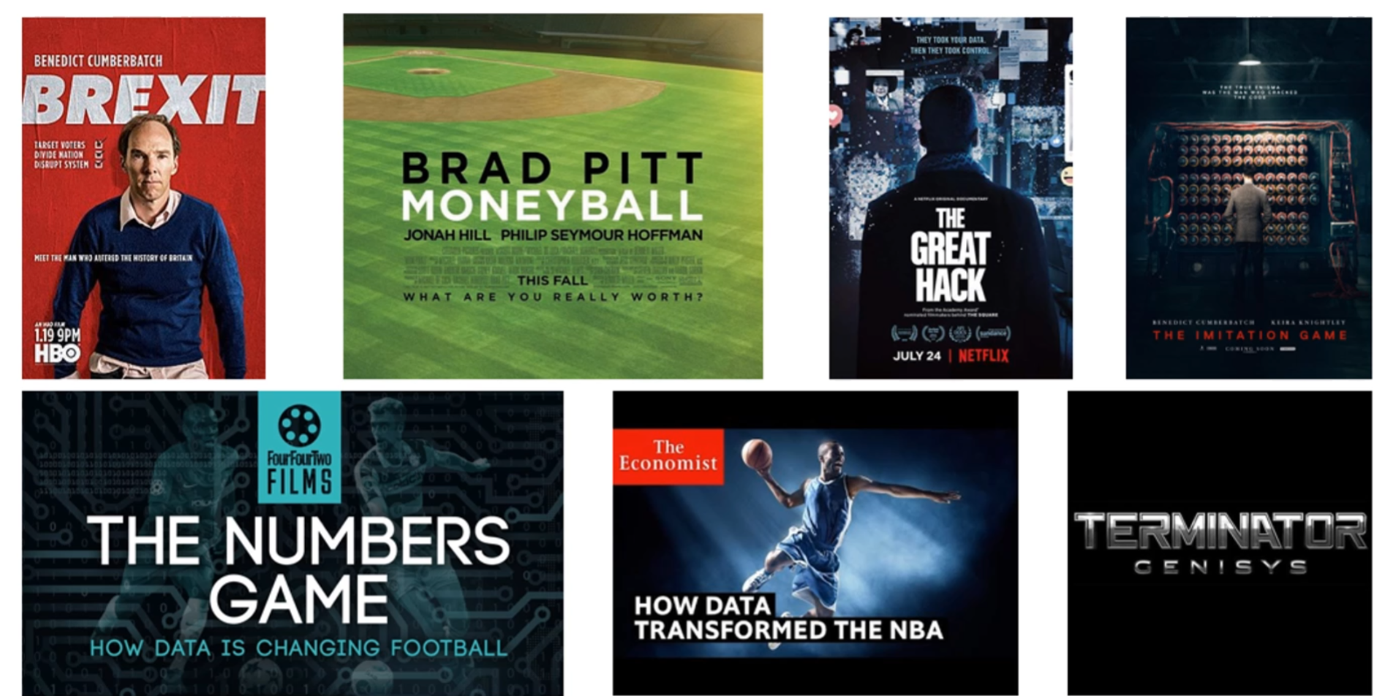

## The Challenge...

* We know that the effectiveness as individuals to contribute success to our organizations or our individual enterprises its really dependent on having the skills and knowledge on how to answer questions of the information found in both our internal and external environments then we have a couple of challenges.

### Top three challenges

1. Having the practical skills to work with data
2. We want to use every shred of data we have available to us. Your art of analytics will develop over time to make sure that you use data efficiently and meaningly and not get lost down the rabbit hole.
   1. ROT
      1. Redundant
      2. Obsolete
      3. Trivial

* The **iceberg principle** holds true for big data

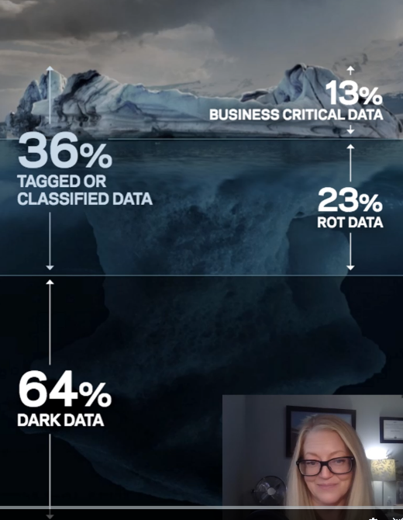

* Dark data is operational data that is not being used. Gartner describes dark data as information assets that organizations collect process and store in the course of their regular business activity but generally fail to use for any other purposes.

## KBQs - Key Business Questions

**The Key Business Question Grid**

* the KBQ grid is a heuristic that helps organizations prioritize their business questions

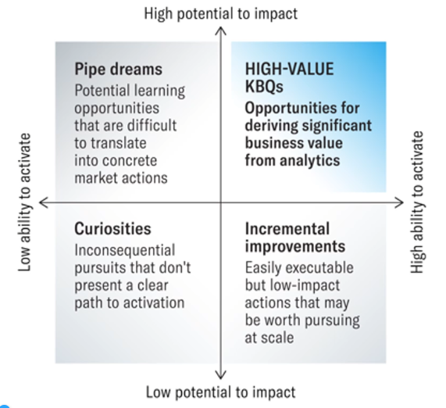

* in summary our ability to obtain a competitive advantage can be linked to our ability to gain meaningful insight on our data and act on it in a meaningful way

## Seth Godin

* When there’s simply data, it’s all noise. It’s impossible for a human being to absorb data without a narrative
* we all generally have a story problem. We need to develop empathy to turn all the data we have assembled into a story that others can understand.

## Business Intelligence How To

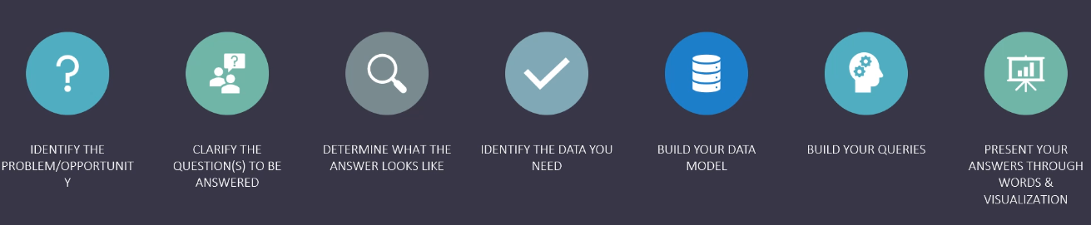

* identify the problem/opportunity
* clarify the questions to be answered (KPI or business questions)
* determine what the answer looks like
* identify the data you need
* build your datamodel
* build your queries
* present your answers through words and visualization

## Technology is Ubiquitous

* every job is now a tech job
* every industry is digital
* The marketer, the finance person, the sales rep all need to have a foothold in technology

## Digital is the New Normal

* the average user has 3 devices
* its all changing how we do things such as online shopping etc
* For example remember we had to book vacations by going into a place to book them but now we can do it all online, renting cars, getting around, listening to music, sending money to people
* Technology is continually changing expectations of how we the consumer, expect we interact and do business with. With a goal of it being easier or more fun.

## Conversion of 4 types of technology:

### SMAC or CAMS

* Social
* Mobile
* Analytics
* Cloud

#### Cloud computing

* as internet connectivity became mainstream for millions of users worldwide and counting and computing power increased due to Moore's Law. We have moved our computer from the desks to the cloud.
* Moore's Law was created in 1965 by intel co founder Gordon E Moore that the number of transistors placed in an integrated circuit or chip doubles every 18 months to 2 years. Microsoft stated that its goal was to have a computer on everyone's desk but now companies like microsoft have shifted their whole business model to enable SASS because we do not have local hardware in fact our computers have gotten so much more powerful that we are using cloud computing. Systems for much of our processing power.

## The Internet of things

* the general availability of the internet and cloud computing has led to the phenomenon we call the internet of things.
* For short IOT is defined as the interconnection via the internet of computing devices embedded in everyday objects that allow them to send and receive data. devices connecting with no human involvement required. This is found in wearables, smart homes, smart cities, health care
* some examples that we can see today include concussion sensors, medical alert watches, sprinkler system.
* Business Insider Predicts IOT solutions will hit 6 trillion dollars by the end of 2022. That is heavily investments in 5G technology which is a prerequisite for a number of technologies that we are talking about especially like things like autonomous driving

## Analytics

Every device we have collects data about what we do, where we are, who we are in contact with. Just like the covid 19 contact tracing. For every website we visit or app we use collects and stores data about what we are doing and where we came to before we were on a app or website

Big data was measured first using the top 3 V’s: velocity, variety, and volume

* Velocity
  + the speed at which data is collected. It is faster than ever.
* variety
  + the different types of data so it is not just about numbers. Its about techsentiment and other information that we can use
* volume
  + The amount of data being collected from everywhere
  + depending who write the list there are are a few more V’s as seen below
* validity
  + the value of data. What is the worth of the data now that we have so much storage available for us. Not all data is created equally
* veracity
  + the quality or trustworthiness of the data. This is important to create our data

## Where is data stored?

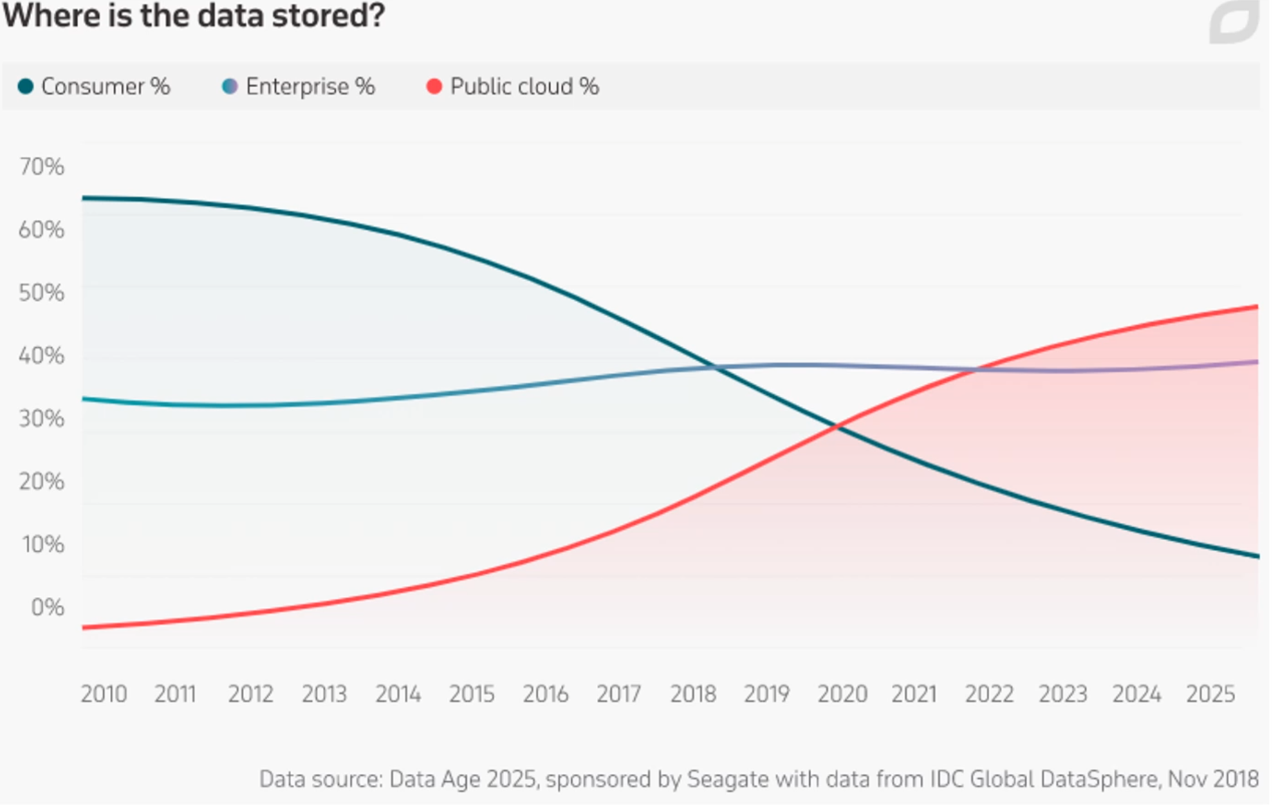

* you can see we are shifting away from personal storage and moving towards public cloud.

## Per Minute - 2020

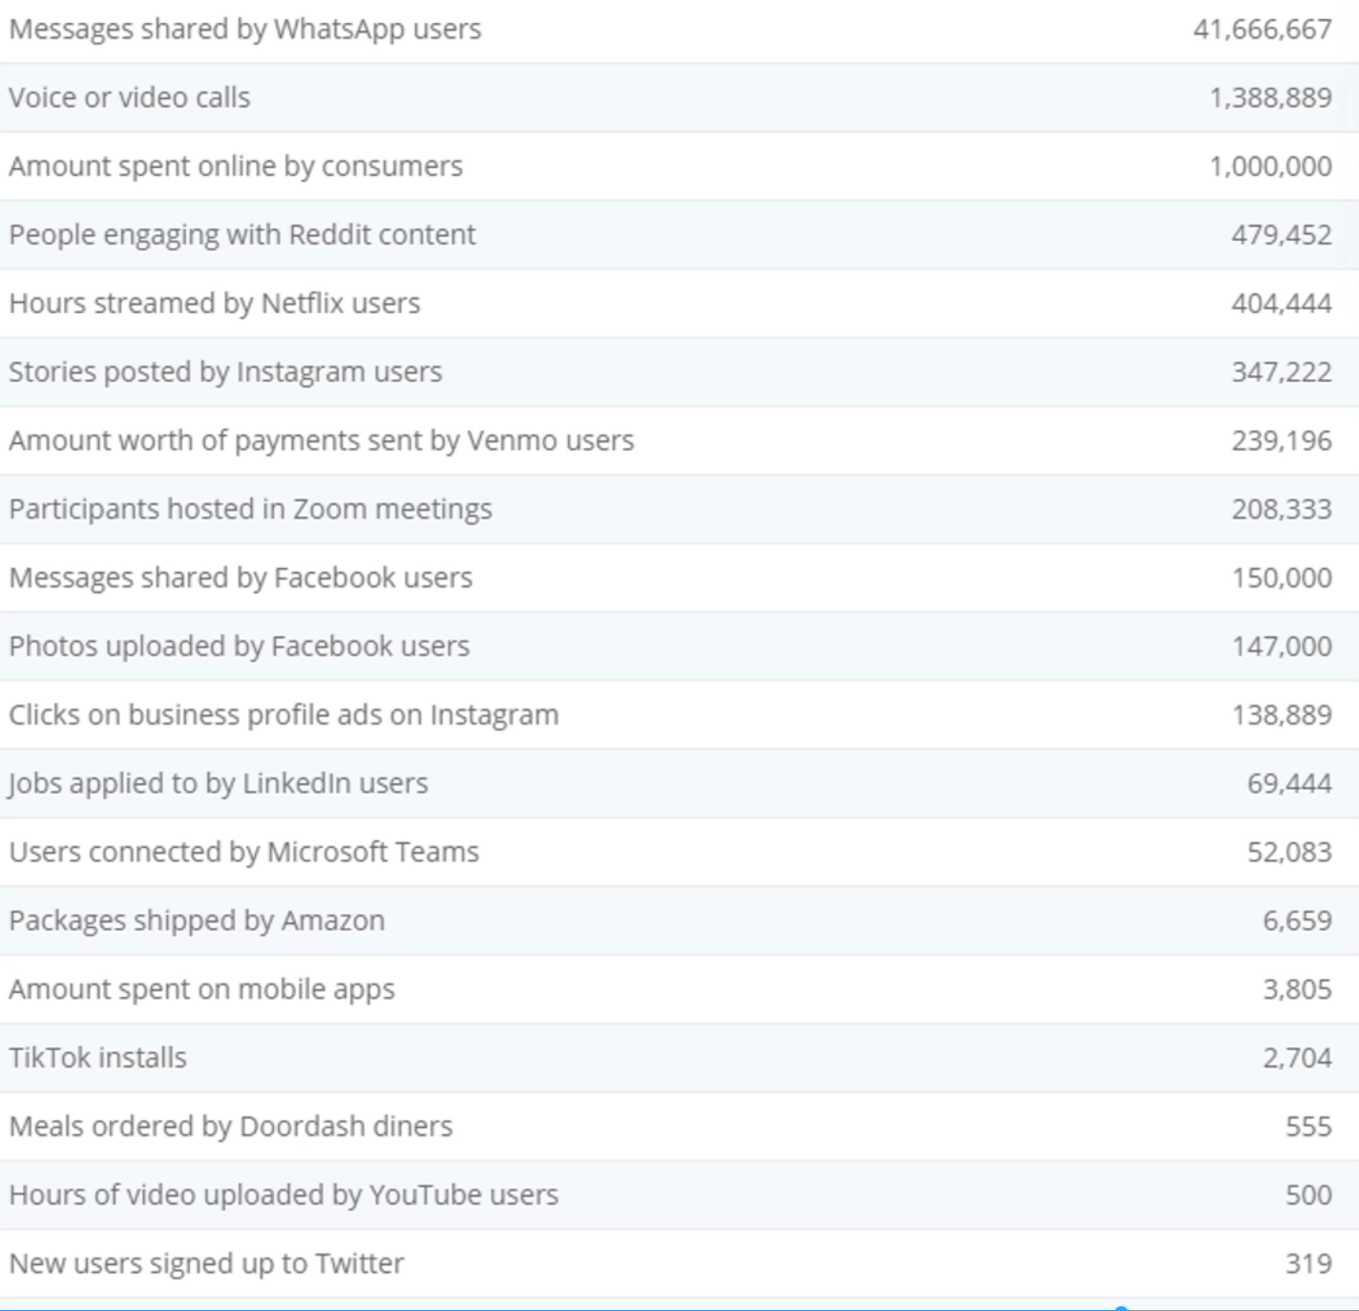

* list of activities online
* per minute states on different social platforms doing different activities in 2020
* Think about the data points that exist behind this. Think about how data is a commodity

## About the World We Live In

* there is no sitting still
* we will either go on the offensive and disrupt or be disrupted

## Today’s Reality

* in short, literacy is not like riding a bike. While Canadians tend to leave the high school level with these skills, it takes practice to retain them, and Canada’s economy does not provide the opportunity to do that for many workers.

## Digital Literacy means:

* the future belongs to learn-it-alls
* there is no hope for know-it-alls